

Chefmaster Buffet Warmer
Instruction Manual

Model

HED240 – Buffet Warmer

Thank you for purchasing your Chefmaster Buffet Warmer. To make full use of the product please read this manual carefully before using the product and keep it safe for future reference.

Safety Tips

- If you find any damage when the product is unpacked, contact your Chefmaster supplier within 24 hours of receipt of goods
- Always position on a flat stable surface
- Repairs should always be carried out by a qualified technician
- Do not use this product outside
- Do not carry when the warmer is hot
- Do not touch base or bulb whilst the unit is in use
- Always switch off and unplug the unit before cleaning
- Move by holding the base of the product
- Ensure the base of the container is clean before using
- If the glass is cracked, disconnect from the power supply and contact your Chefmaster distributor
- Always store the appliance in a flat and firm surface
- Do no place heavy objects on top of the unit
- If the power cord becomes damaged it must be replaced by a qualified technician
- This product is not designed to be used by persons with reduced physical or mental capabilities, lack of experience or knowledge, unless they are given suitable supervision, this includes children.

Pack Contents

- 1 x Chefmaster Buffet Warmer
- 2 x Infrared Bulbs

Before Use

- Remove all packaging including all protective plastic, from your Chefmaster Buffet Warmer
- Position on a flat and firm surface
- Wipe the Buffet Warmer with a damp soft cloth before first use
- Ensure the Infrared Bulbs are installed properly
- Plug your Chefmaster Buffet Warmer into the mains
- The Buffet Warmer will now be ready to turn on

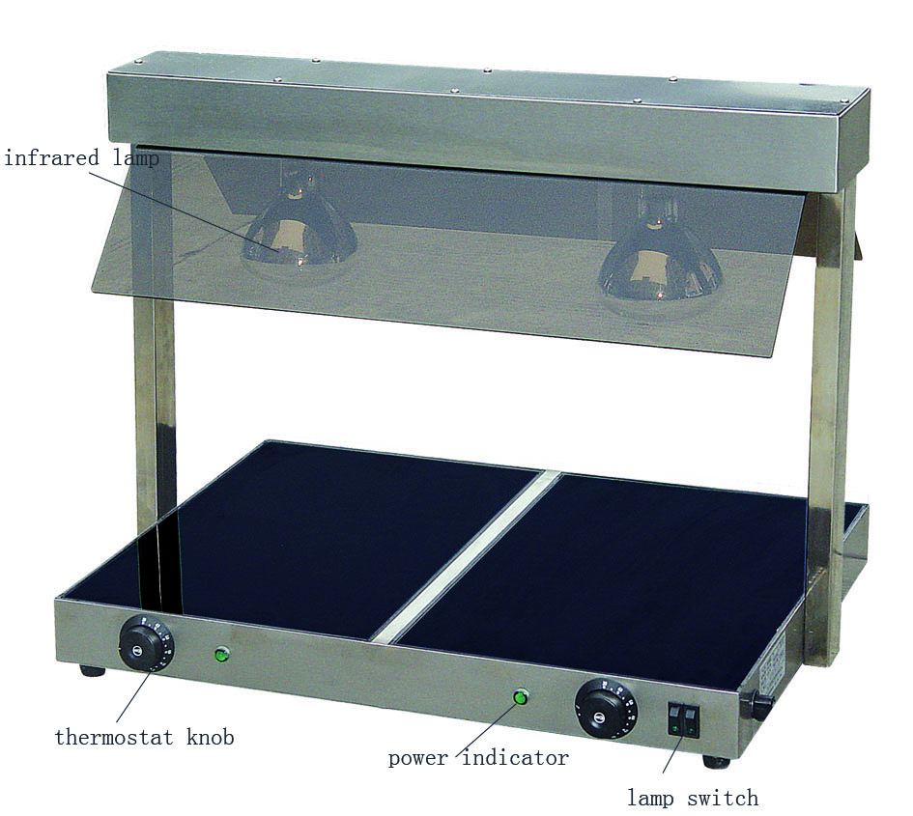

Operation

- Ensure the appliance is plugged in and the power indicators are on
- Turn the thermostat dial(s) to the required setting/Turn the infrared bulb(s) by selecting the lamp switch button(s)
- When the desired temperature is reached, the unit will keep warming. The green power indicators will go off and on repeatedly as the thermostat maintains a constant temperature
- Place food containers on the Buffet Warmer.
- The unit holds temperature of 30-85 °C

NOTE: Only use food containers with flat & smooth bases, such as Gastronorm Pans in sizes of 1/1 or 1/2.

Cleaning & Maintenance

- Before cleaning, disconnect the Buffet Warmer from the electricity supply
- Once the warmer is cooled, wipe with a damp soft cloth
- DO NOT submerge the unit in water or use water sprays to clean
- Always clean your Chefmaster Buffet Warmer daily

Troubleshooting

Fault | Possible Cause | Solution
Buffet Warmer not working | The unit is not switched on  The plug or lead are damaged  The fuse has blown  Internal wiring fault | Check the unit is plugged in and switched on  Contact your Chefmaster distributor  Replace the fuse  Contact your Chefmaster distributor
Infrared Lamp is not on | The bulbs are not switched on  The bulbs are not installed properly  The bulbs are burnt out | Check the unit is plugged in and turn on the lamp with switch buttons  Switch off the product, then tighten the bulbs clockwise & switch on again  Contact your Chefmaster distributor

Transportation and Storage

Please handle your Buffet Warmer with care to prevent any damage to the unit and internal parts. The Buffet Warmer should be stored somewhere which is ventilated and has non-corrosive gas.

Do not store any flammable objects near the equipment.

Technical Information

HED240 – Buffet Warmer

Voltage ~230v, 50/60Hz
Power 1000watt
Dimension 730 x 580 x 550mm
Weight 14kg

- Chefmaster Buffet Warmer is supplied with a 3 pin plug and lead with a 13 amp fuse
- Appliance must be earthed
- If in doubt contact a qualified electrician or your Chefmaster distributor

Disposal

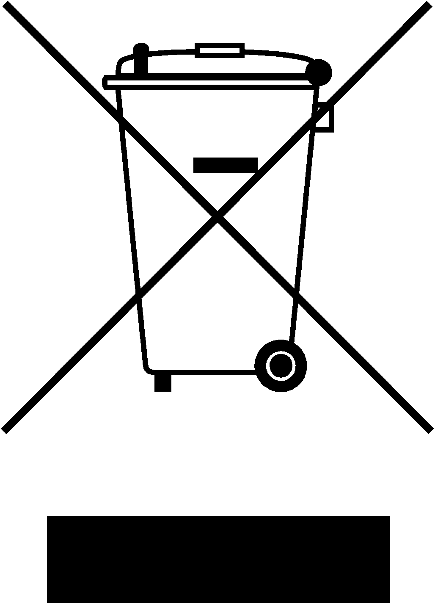

Under WEEE regulations this product must not be disposed of as household waste. To prevent damage to the environment and humans this product must be disposed of in an approved and environmentally friendly recycling process. For more information on how to dispose of this correctly please contact your Chefmaster distributor or local authority responsible for waste disposal.

Compliance


All Chefmaster parts and products have under gone a stringent testing process to ensure that comply with all European standards and specifications.
All Chefmaster products carry the CE approval symbol.

